Draw a line to match the pictures to each type of pollutant

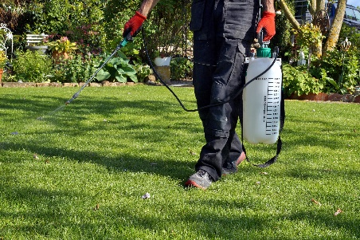

Pesticides sprayed on a yard Sediment

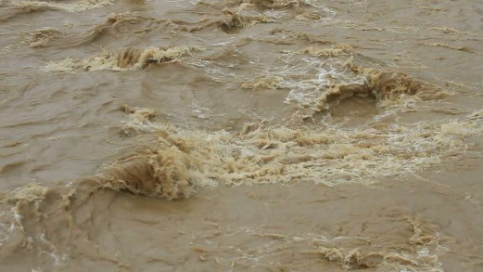

Erosion Nutrients

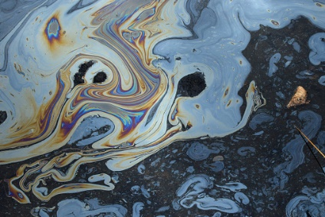

Oil and gas Organic

Solid waste left behind Toxins/Trash

